Dear Families,
This year we will be utilizing a writer’s notebook during our language arts block. The writer’s notebook will become a very special and personal tool for our flourishing authors. In order to make this notebook “our own” and remind us of the many things we have to write about, we are asking students to decorate their writer’s notebook at home. Students could use the following as decorations:
- Photographs
- ticket stubs
- pictures from magazines
- quotes
- stickers
- drawings
- anything else that will provide them with starting places and ideas that will grow into great writing pieces.
- If you wish, you may cover the decorated notebook with clear packing tape or contact paper to protect it and ensure it lasts throughout the year.
Please DO NOT add any entries in the book; we will be doing that in class.
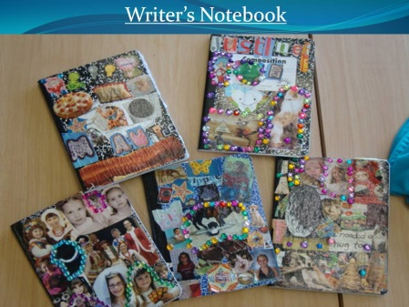
Please see below for the date your decorated notebook needs to be back in school so we can begin the fun work of becoming writers. As always, feel free to contact me with questions.
Sincerely,
Ms. Diapoulis

Please bring your decorated notebook to school by Friday, September 18th

