Geography Unit Study Guide
Test Friday, September 25th

Locations of places can be described in relative terms. Relative location may be described using terms that show connections between two places such as
- next to
- near
- bordering

Terms to know:

Fall Line: the natural border between the Coastal Plain (Tidewater) and Piedmont regions, where waterfalls prevent further travel on the river.

Peninsula: a piece of land bordered by water on three sides.

Bordering States and Bodies of Water of Virginia
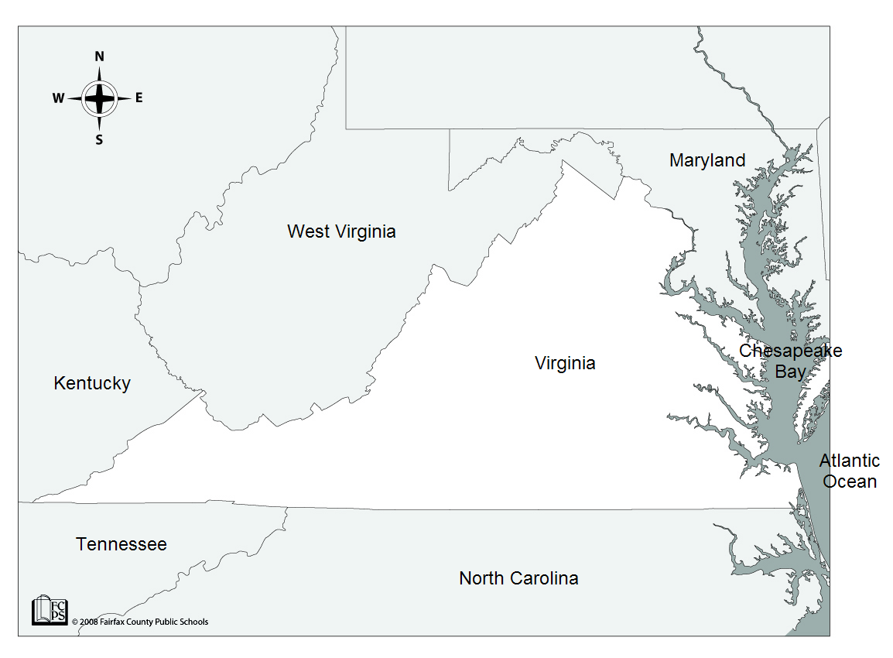

Virginia’s Borders | Silly Sentence
Maryland | Mustard
West Virginia | With
Kentucky | Ketchup
Tennessee | Tastes
North Carolina | Nasty

Rivers of Virginia
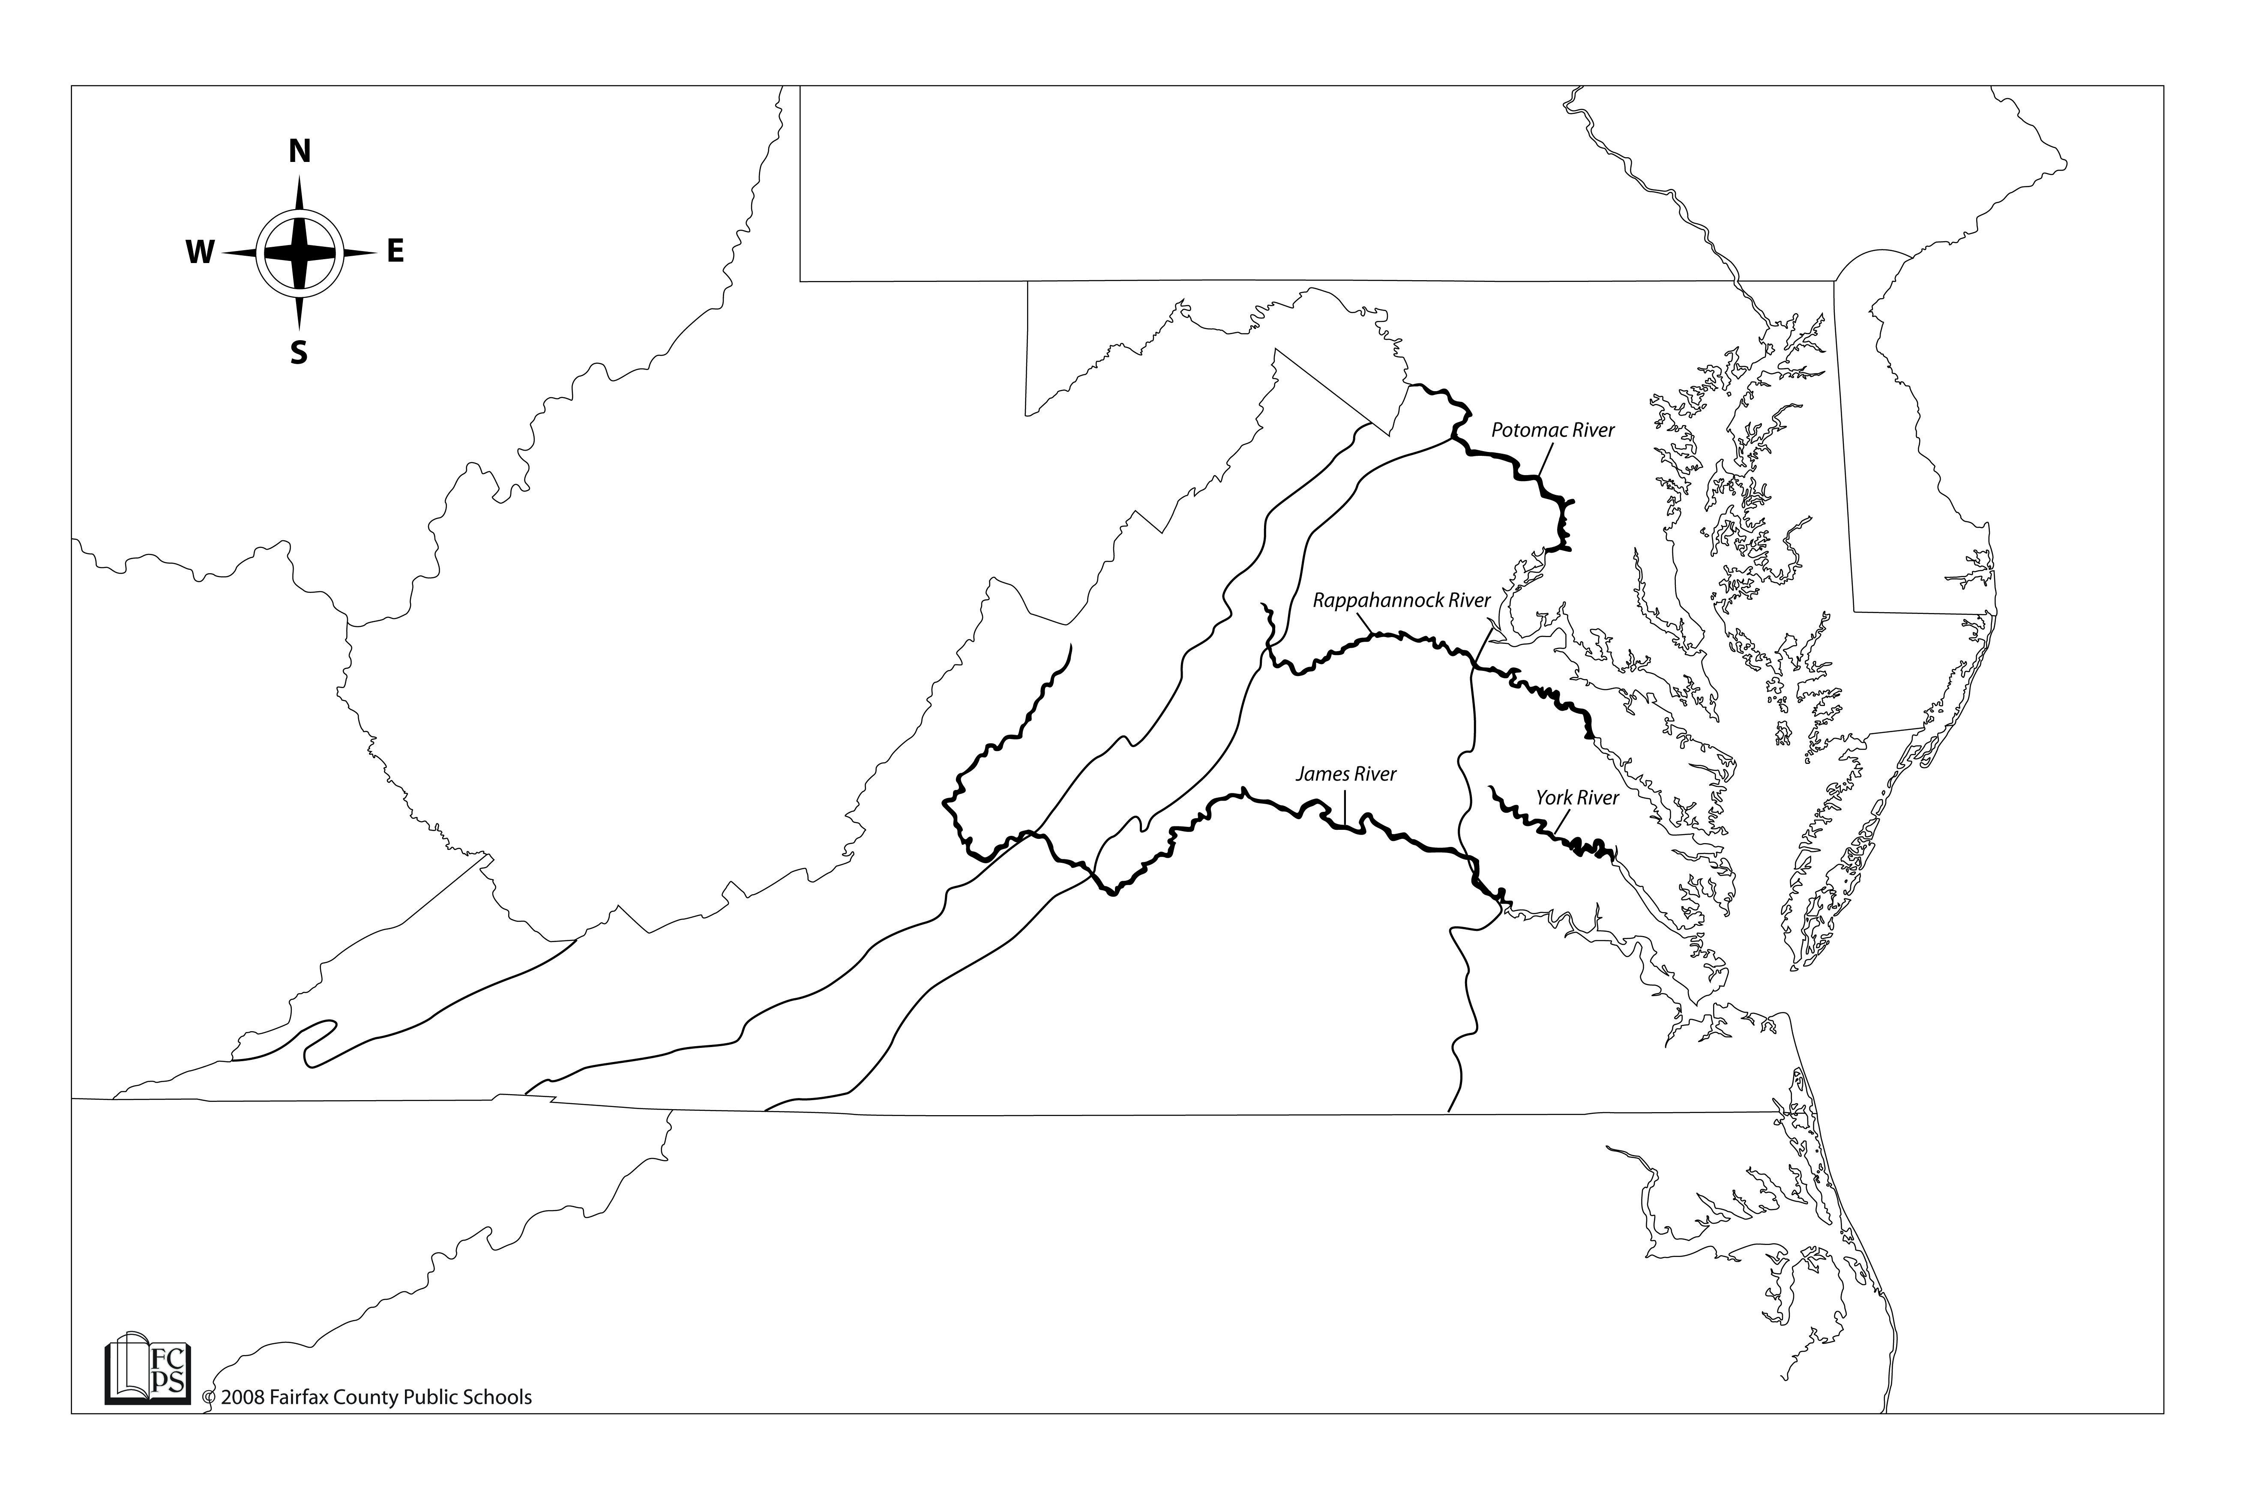

Virginia’s Rivers | Silly Sentence
Potomac River | Please
Rappahannock River | Remove or Remember
York River | Your
James River | Jacket

- each river was a source of food and provided a pathway for exploration and settlement of Virginia
- each of these rivers flow into the Chesapeake Bay

Cities and Rivers

Virginia’s Cities | Silly Sentence
Alexandria is on the Potomac River | Alex likes potatoes.
Fredericksburg is on the Rappahannock River | Fred likes to rap
Yorktown is on the York River
Jamestown is on the James River
Richmond is on the James River | King James is rich

More Water Features

Atlantic Ocean
- provided transportation links between Virginia and other places (e.g., Europe, Africa, Caribbean)

Chesapeake Bay
- provided a safe harbor
- was a source of food and transportation

Lake Drummond
- located in the Coastal Plain (Tidewater) region
- shallow natural lake surrounded by the Dismal Swamp

Dismal Swamp
- located in the Coastal Plain (Tidewater) region
- variety of wildlife
- George Washington explored and surveyed the Dismal Swamp.

Eastern Shore
- a peninsula
- bordered by the Chesapeake Bay to the west and the Atlantic Ocean to the east

Regions of Virginia
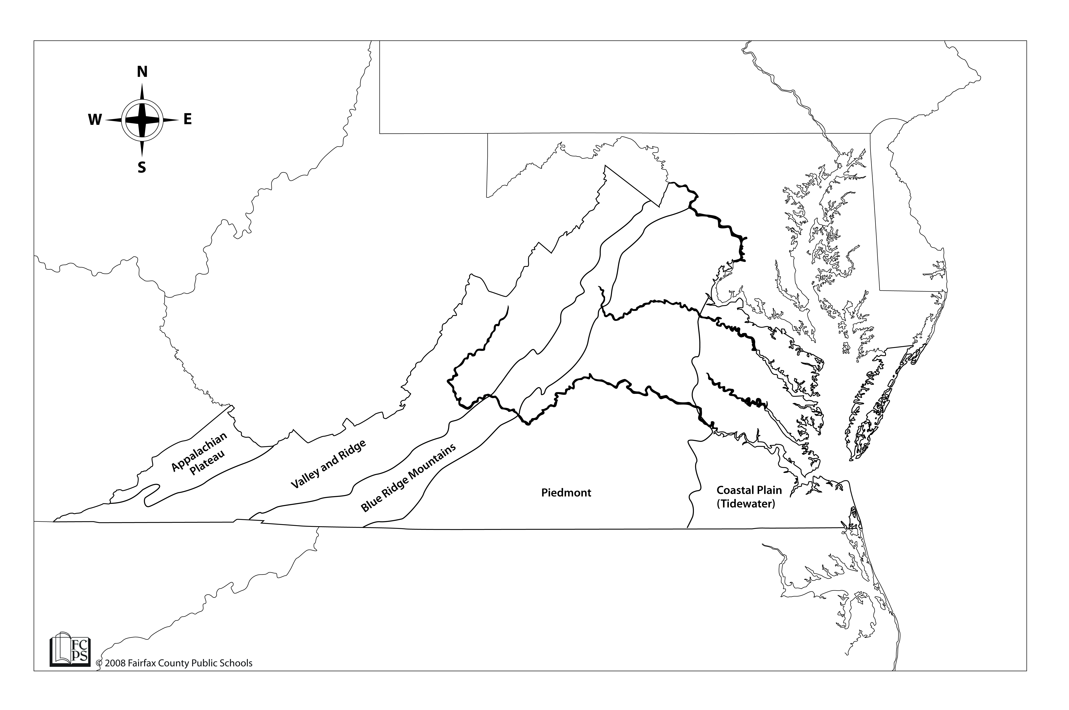

Five Geographic regions

Coastal Plain (Tidewater)
- flat land
- location near Atlantic Ocean and Chesapeake Bay
- includes the Eastern Shore
- east of the Fall Line

Piedmont
- means “land at the foot of mountains”
- rolling hills
- west of the Fall Line

Blue Ridge Mountains
- old, rounded mountains
- part of Appalachian mountain system
- located between the Piedmont and Valley and Ridge regions
- source of many rivers

Valley and Ridge
- includes the Great Valley of Virginia
- includes other valleys separated by ridges
- part of the Appalachian mountain system
- located west of the Blue Ridge Mountains

Appalachian Plateau
- located in Southwest Virginia
- only a small part of the plateau is located in Virginia

Products and Industries

Coastal Plain (Tidewater) region
- seafood | - peanuts
- military bases | - tourism
- shipbuilding

Piedmont region
- tobacco products | - information technology
- Federal and state government | - farming
- horse industry

Blue Ridge Mountain region
- apples | - recreation
- farming

Valley and Ridge region
- poultry | - apples
- dairy | - beef
- farming

Appalachian Plateau region
- coal | - coal mining

